**Experiment Title 3.3**

**Student Name: Sahul Kumar Parida UID: 20BCS4919**

**Branch: CSE Section/Group: WM-904/B**

**Semester: 5th**

**Subject Name: Project Based Learning using Java**

**Subject Code: 20CSP-321**

**1. Aim/Overview of the practical:**

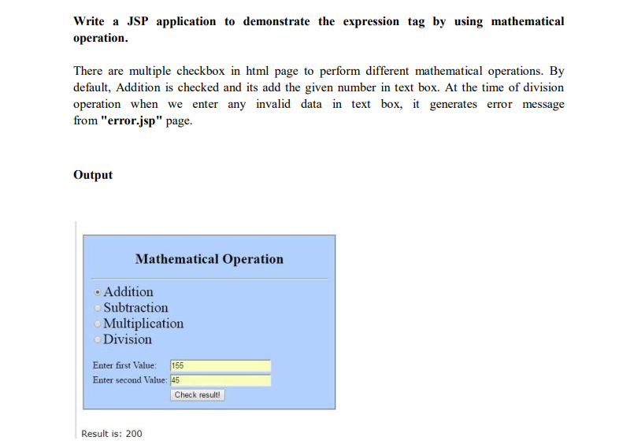

**2. Software/Hardware Requirements:**

# Windows

# BlueJ (Java IDE)

# JRE (Java Runtime Environment)

**3. Steps for experiment/practical/Code:**

**input.html**

<html>

<title>Sample Example </title>

<body>

<form method="post" action="index.jsp">

<fieldset style="width:30%; background-color:#b3d1ff">

<h2><center> 20BCS4919_Sahul</center></h2>

<h2><center> Mathematical Operation</center></h2>

<hr>

<font size=5 face="Times New Roman">

<input type="radio" name="a1" value="add" checked>Addition</input><br>

<input type="radio" name="a1" value="sub">Subtraction</input><br>

<input type="radio" name="a1" value="mul" >Multiplication</input><br>

<input type="radio" name="a1" value="div" >Division</input><br>

</font>

<table>

<tr>

<td>Enter first Value:</td>

<td> <input type="text" name="t1" value=""></td>

</tr>

<tr>

<td>Enter second Value: </td>

<td><input type="text" name="t2" value=""></td>

</tr><br>

<tr>

<td></td>

<td><input type="submit" name="result" value="Check result!"></td>

</tr>

</table>

</fieldset>

</form>

</body>

</html>

**index.jsp**

<%@ page errorPage="error.jsp" %>  
<html>  
    <body>  
        <H1><center>Result for <%=request.getParameter("a1")%></center></H1>  
        <%  
            String num1=request.getParameter("t1");    
            String num2=request.getParameter("t2");    
    
            int i=Integer.parseInt(num1);    
            int j=Integer.parseInt(num2);    
  
            int k=0;  
            String str=request.getParameter("a1");  
            if(str.equals("add"))  
                k=i+j;  
            if(str.equals("sub"))  
                k=i-j;  
            if(str.equals("mul"))  
                k=i*j;  
            if(str.equals("div"))  
                k=i/j;  
        %>  
        Result is: <%=k%>  
    </body>  
</html>

**error.jsp**

<%@ page isErrorPage="true" %>    
    
<h3>Sorry an exception occured!</h3>    
    
Exception is: <%= exception %>

#### **web.xml**

<web-app>  
    <servlet>  
        <servlet-name>xyz</servlet-name>  
        <jsp-file>/input.html</jsp-file>  
    </servlet>  
    <servlet-mapping>  
        <servlet-name>xyz</servlet-name>  
        <url-pattern>/test</url-pattern>  
    </servlet-mapping>  
</web-app>

**4. Result/Output/Writing Summary:**

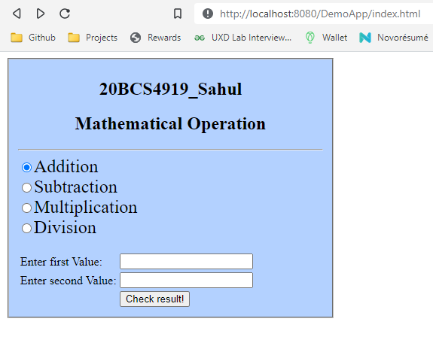

Addition

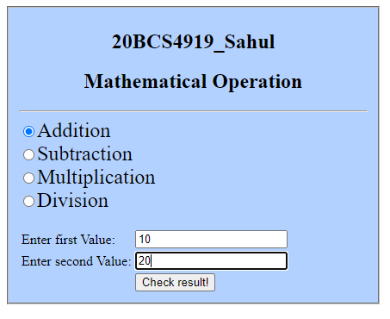

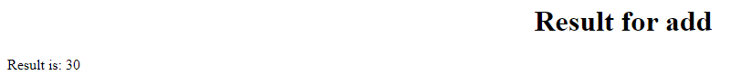

Subtraction

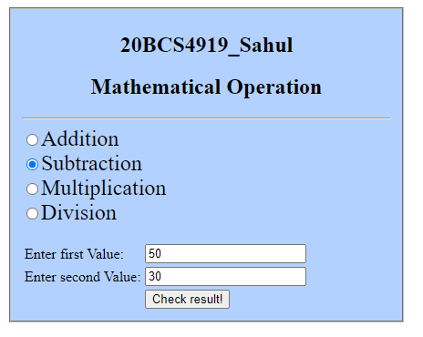

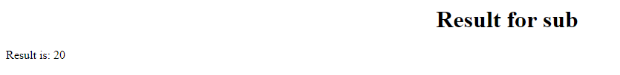

Multiplication

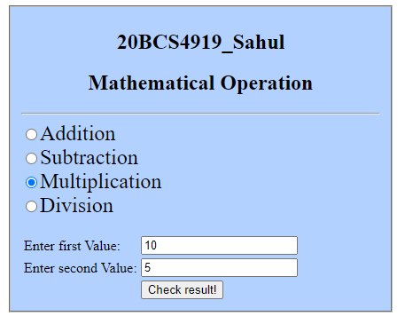

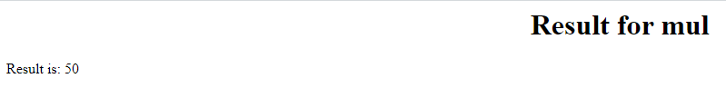

Division

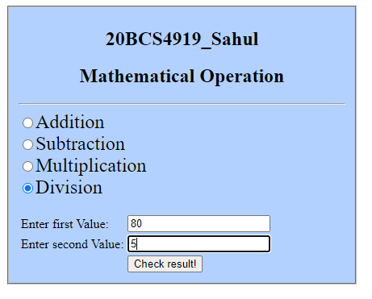

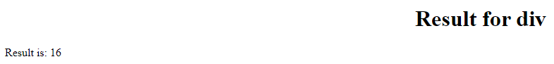

**Learning outcomes (What I have learnt):**

1. Java Server Pages (JSP) is a server-side programming technology that enables the creation of dynamic, platform-independent method for building Web-based applications. JSP have access to the entire family of Java APIs, including the JDBC API to access enterprise databases.
2. Java Scriplets: - It allows us to add any number of JAVA code, variables and expressions.
3. JSP Expression: - It evaluates and convert the expression to a string.